GET COUNT – REQUEST:

The client attempting to get the product count request from the server

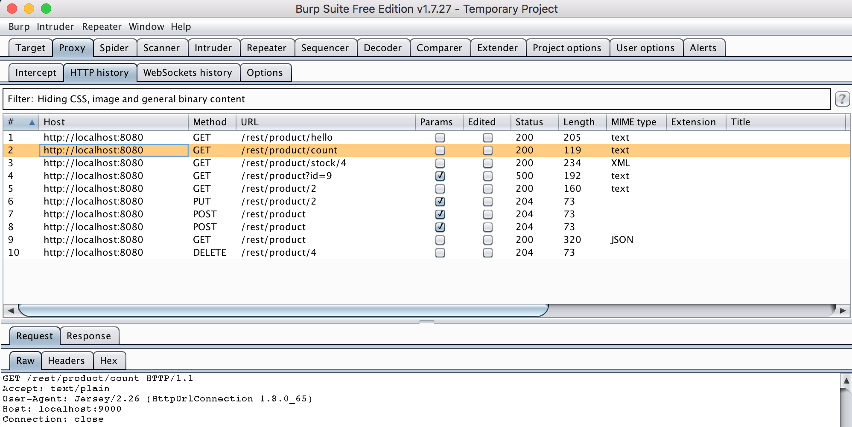

GET COUNT – RESPONSE:

The response from the server to the client display the count number

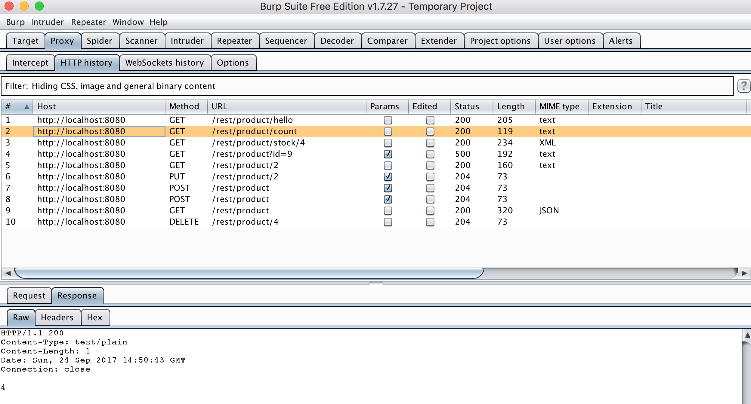

PUT PRODUCT – REQUEST:

The client requesting to insert a product with id 2 to the server

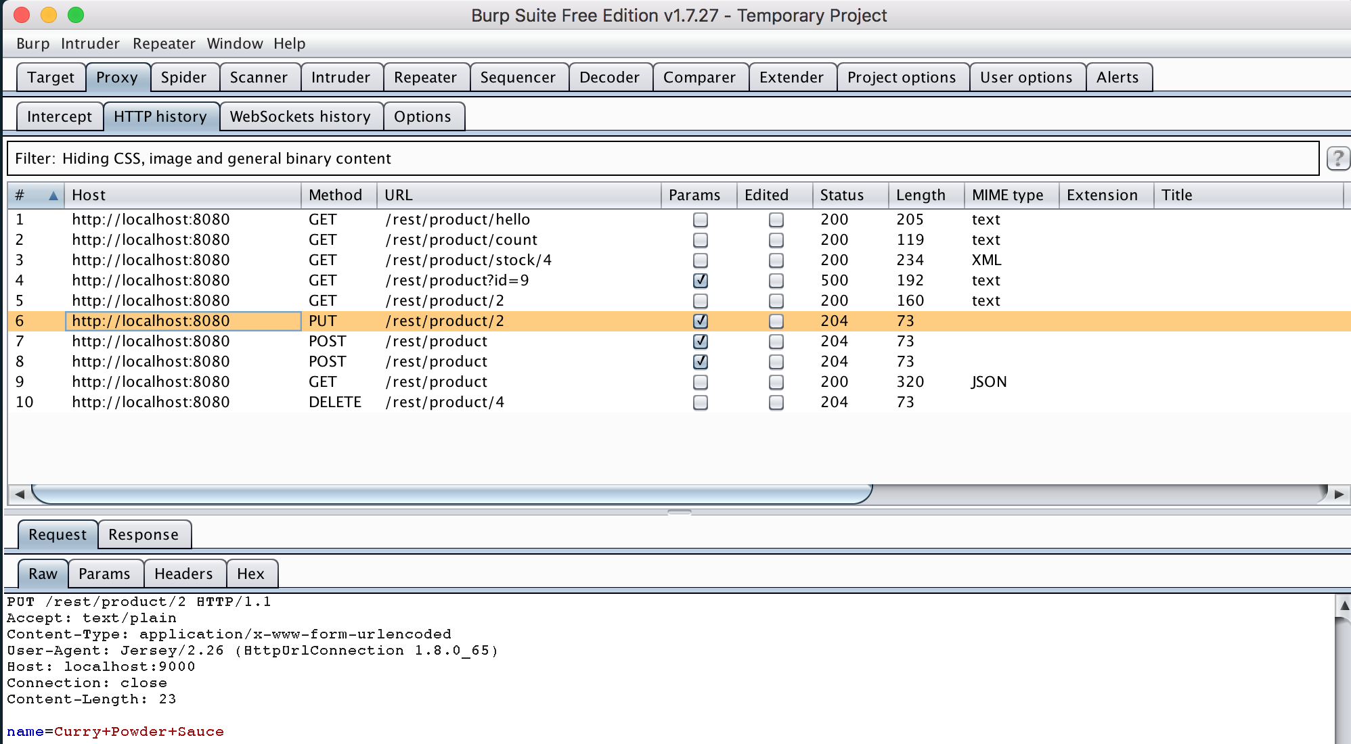

PUT PRODUCT – RESPONSE:

The response from the server to the client with product inserted and closes the connection

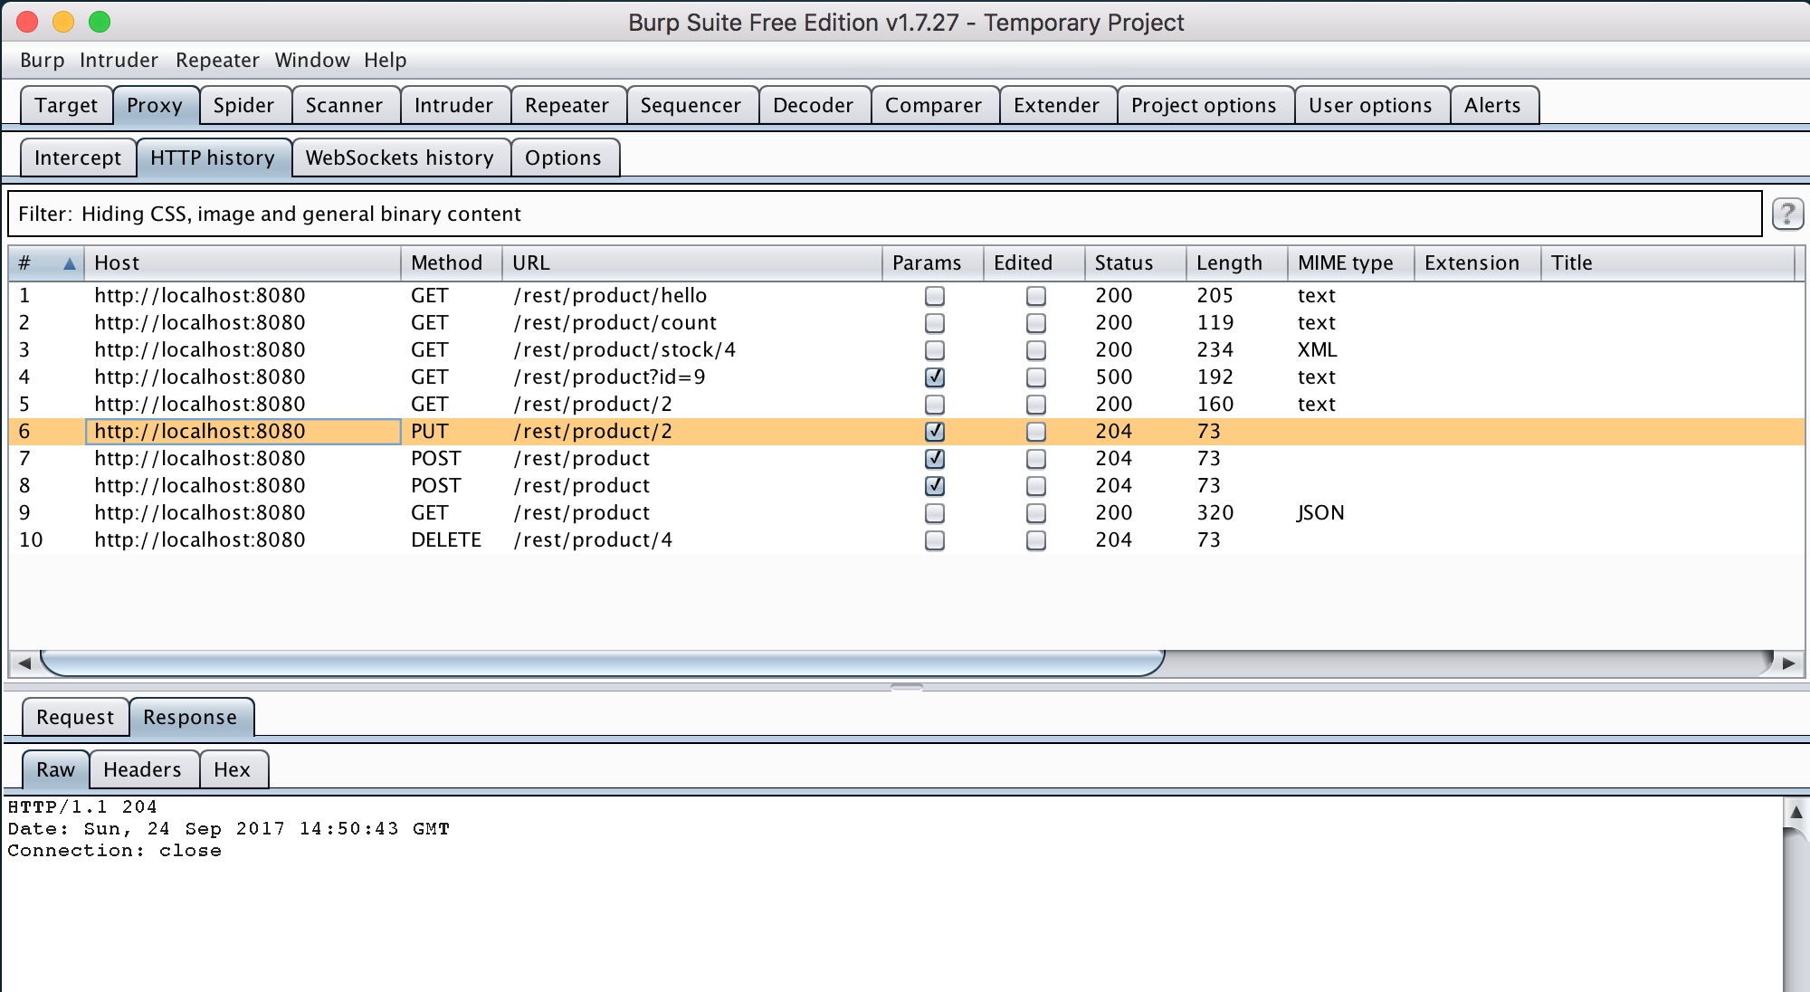

POST PRODUCT – REQUEST:

The client requesting to create a product with id 5 and name Pepperino Sauce to the server

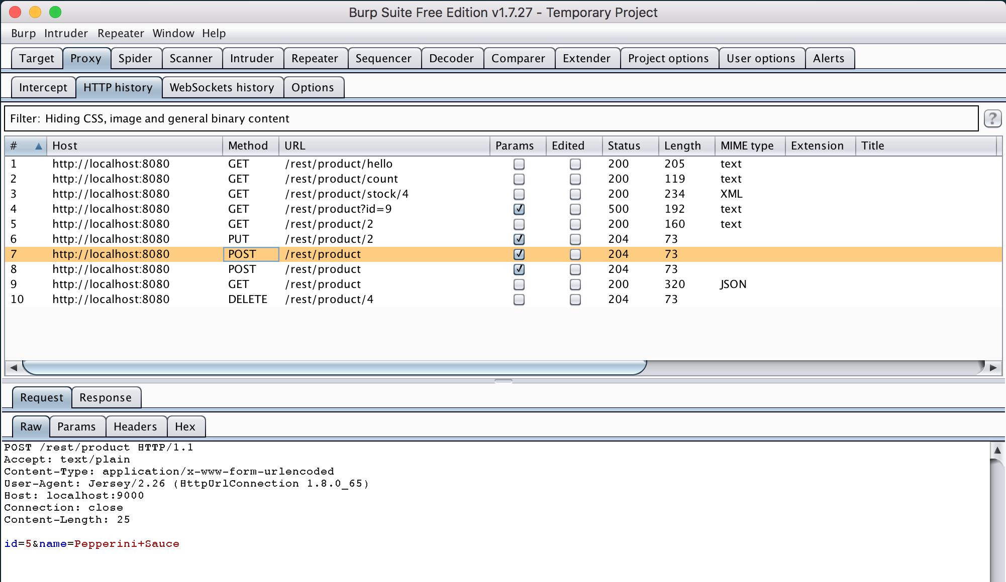

POST PRODUCT – RESPONSE:

The response from the server to the client with no errors with product created and closing the connection

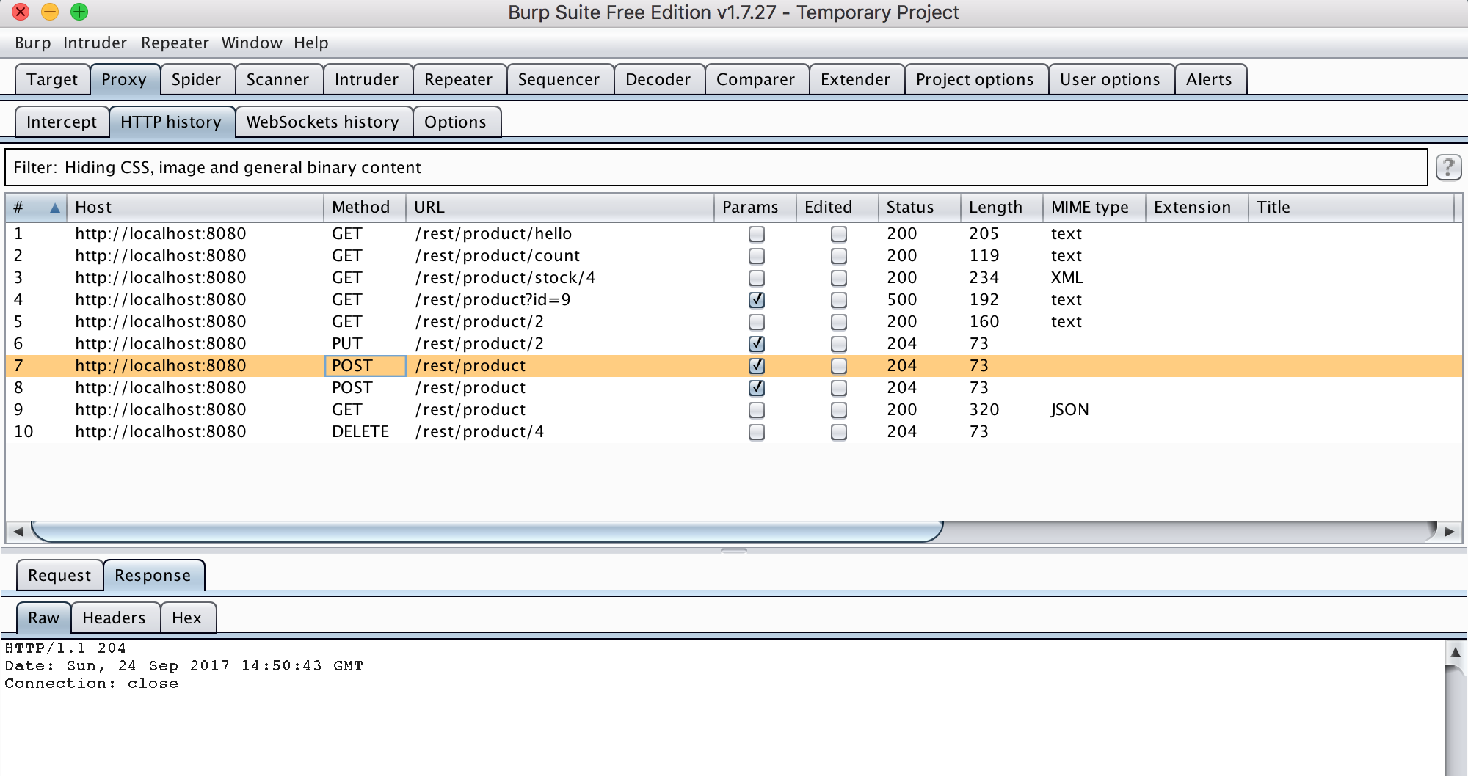

DELETE PRODUCT – REQUEST:

The client attempting to delete a product with a specific id

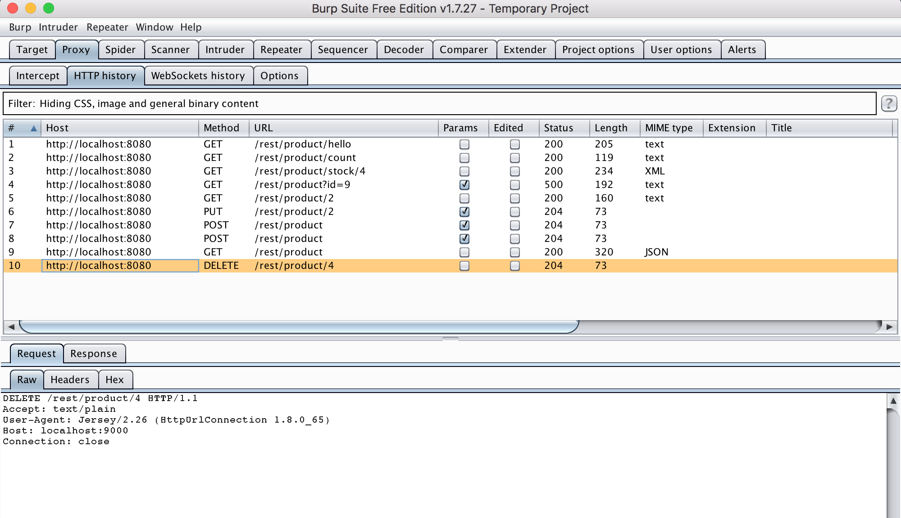

DELETE PRODUCT – RESPONSE:

The response from the server to the client with no errors that product has been deleted

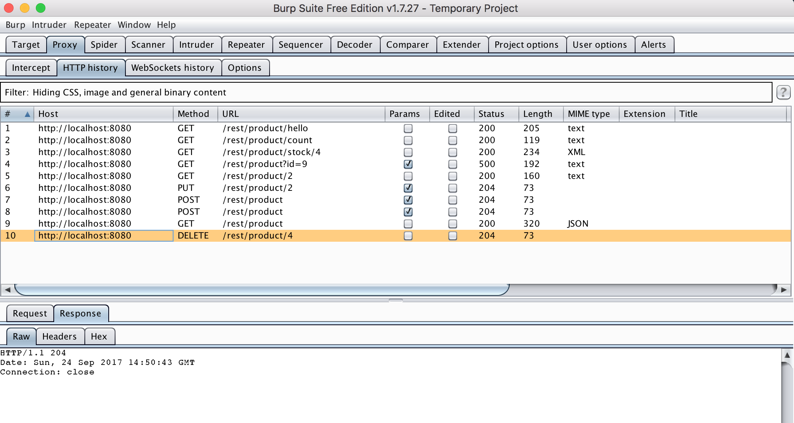

GET PRODUCT - OWN CUSTOM MESSAGE DISPLAY:

Response to the client that the requested id “9” from Query retrieval is not possible cause it does not exist

